Software Development Engineer
Qualification Assignment

Name:Ayman Abdullah Subbagh
Date:6/9/2022

Thank you for your interest in joining Freightos team and congratulations on being shortlisted for this employment opportunity at Freightos.

This 24-hour assignment will test your skills relating to the professional execution of the Software Development Engineer position major job responsibilities. This assignment will test your level of knowledge mainly in Computer Science Fundamentals (coding, algorithms and data structures), OO, and problem solving among other skills.

Introduction
Vending machines can be be of different types. Some vending machines are dedicated to coffee, some are dedicated to drinks, and others are dedicated to snacks. For this assignment, you will implement a Snack Vending machine.

Deliverables:
- Provide a UML diagram/s to illustrate your understanding of Object Oriented design techniques and concepts.
- Provide a code skeleton to the design.
- Implement the SnackMachine class
- Provide a test suite to the main class.

Specifications of the Snack Machine
The Snack Machine has the following characteristics:
- Money Slots: the machine accepts money of the following types:
  - CoinSlot: There are four denominations: • 10c • 20c • 50c • $1
  - CardSlot : all cards accepted
  - Notes Slot :20$ and 50$ only
  - Machine only accepts USD currency
- Snack Slots
  - The machine has five rows to display snack items.
  - Each row has 5 columns to pile the items.
  - Each column has a number.
- Keypad
Users can select the items to be purchased using a keypad.

SnackMachine app file architecture:
Freightos assignment/
└── diagrams/
├── activity_diagram_page_jpeg
└── useCase_diagram_diagram_jpeg
└── main/
└── snackMachie/
├── __pycache__/
├── __init__.py
└── snackMachine.py
└── tests/
├── __pycache__/
├── __init__.py
└── tests.py
└── utilties/
├── __pycache__/
├── __init__.py
└── utils.py

main.py
from tests.tests import Test
from snackMachine.snackMachine import SnackMachine
from utilties.utils import *

# Check if app is being executed directly
if __name__ == '__main__':
snackMachine = SnackMachine()
print(snackMachine.items_prices)
print("Please press an item of your choice between 1-25.")
pressed_keypad = int(input())
state = False

try:
# Check if item exist
if snackMachine.check_item(pressed_keypad):
# Customer select the payment method
print('Would you like to pay with credit card? ')
print('1: Yes.')
print('2: No.')
try:
if input() == '1':
credit_card_info = "4325-8497-9560-9817"
# validate card
if validate_card(credit_card_info):
# complete payment
state, change = snackMachine.pay_with_card(credit_card_info, pressed_keypad)

else:
# keep looping until amount is sufficient
while not snackMachine.is_amount_sufficient(pressed_keypad, snackMachine.user_amount):
money = input(f"Insert money; Machine accepts {snackMachine.accepted_coins} and {snackMachine.accepted_notes}.")

# Check currency
if money.startswith('$') or money.endswith('$'):
snackMachine.insert(extract(
money,
money.find('$')
))
print(f"\tHere's Your amount of money: {snackMachine.user_amount}$")
state, change = snackMachine.is_there_change(
snackMachine.get_price(pressed_keypad),
snackMachine.user_amount
)
else:
print('The Machine only accepts US dollars')
# Handle KeyboardInterrupt Error
except KeyboardInterrupt:
print('\naborted')

print(f"item number {pressed_keypad} dispensed successfully.")

# Check for change
if state:
print(f"You have change of amount {change}.")
print("Change dispensed successfully.")
snackMachine.user_amount = 0
# Handle KeyboardInterrupt Error
except KeyboardInterrupt:
if snackMachine.user_amount > 0:
print(f"\nYour money has been dispensed successfully: {snackMachine.user_amount}$.")
# Run Test cases
Test.main()

__init__.py
import snackMachine

snackMacine.py
from utilties.utils import fake_credit, get_card_info, format_float
import random

# Creating class instance
class SnackMachine:
accepted_coins = [0.1, 0.2, 0.5, 1]
accepted_notes = [20, 50]
user_amount = 0

items = list(range(1,26))
prices = [float(str(random.uniform(0.1, 20))[:4:])
for i in range(len(items)+1)]

# genrated prices for each item
items_prices = dict(zip(items, prices))
# un-comment the list below for a static item price
# items_prices = {1: 17.7, 2: 0.35, 3: 11.5, 4: 17.7, 5: 3.38,
# 6: 16.9, 7: 3.85, 8: 5.75, 9: 4.22, 10: 16.4,
# 11: 6.15, 12: 18.6, 13: 19.7, 14: 15.5, 15: 16.1,
# 16: 17.1, 17: 9.62, 18: 14.4, 19: 0.15, 20: 4.73,
# 21: 16.8, 22: 9.29, 23: 9.47, 24: 7.45, 25: 15.6}

# Check if item exist
def check_item(self, item):
if item in self.items:
return True
else:
return False

def get_price(self, item):
'''
return the price of the item
'''
print(f"item {item} price is: {self.items_prices[item]}$.")
return self.items_prices[item]

def insert(self, money):
if self.is_money_valid(money):
self.user_amount += money
else:
print(f"The machine only accepts: {self.accepted_coins}, and {self.accepted_notes}.")

# is money from any of the machine's category
def is_money_valid(self, money):
if money in self.accepted_coins:
return True
elif money in self.accepted_notes:
return True
else:
return False

# is the amount sufficient
def is_amount_sufficient(self, item, money):
if money >= self.items_prices[item]:
return True
else:
return False

def is_there_change(self, price, amount):
if amount-price > 0:
return True, format_float(amount-price)
else:
return False, format_float(amount-price)

def pay_with_card(self, credit_card_info, item):
card_balance = float(get_card_info(credit_card_info)['MoneyRange'])
if self.is_amount_sufficient(item, card_balance):
return True, float(
self.recur_change(
format_float(
card_balance - self.get_price(item)
)
)
)

else:
print("Card Declined Insufficient Money.")
return False, 0.0

def recur_change(self, change):
'''
Recursive function to return the change from the machine cash box.
'''
if change == 0 :
return 0
else:
if change >= 50:
return 50 + self.recur_change(format_float(change)-50)
elif change < 50 and change >= 20:
return 20 + self.recur_change(format_float(change)-20)
elif change < 20 and change >= 1:
return 1 + self.recur_change(format_float(change)-1)
elif change > 1 and change >= 0.5:
return 0.5 + self.recur_change(format_float(change)-0.5)
elif change > 0.5 and change >= 0.3:
return 0.3 + self.recur_change(format_float(change)-0.3)
elif change > 0.3 and change >= 0.2:
return 0.2 + self.recur_change(format_float(change)-0.2)
elif change > 0.2 and change >= 0.1:
return 0.1 + self.recur_change(format_float(change)-0.1)

__init__.py
import tests

tests.py
from snackMachine.snackMachine import SnackMachine
from utilties.utils import *
import unittest
class Test(unittest.TestCase):

# Test that item exist
def testItemExist(self):
# item exist case
res = SnackMachine().check_item(2)
self.assertEqual(True, res)

# Test that item doesn't exist
def test_item_not_exist(self):
# item doesn't exist case
res = SnackMachine().check_item(-1)
self.assertEqual(False, res)

# Test that coins is valid
def test_insert_valid_coins(self):
# cois is valid
res = SnackMachine().is_money_valid(0.2)
self.assertEqual(True, res)

# Test that notes is valid
def test_insert_valid_notes(self):
# notes is valid
res = SnackMachine().is_money_valid(50)
self.assertEqual(True, res)

# Test that money isn't valid
def test_insert_not_valid_coins(self):
# money isn't valid
res = SnackMachine().is_money_valid(100)
self.assertEqual(False, res)

# Test if the amount sufficient
def test_amount_not_sufficient(self):
# amount is not sufficient
res = SnackMachine().is_amount_sufficient(7,1)
self.assertEqual(False, res)

# Test if the amount sufficient
def test_amount_sufficient(self):
# amount is sufficient
res = SnackMachine().is_amount_sufficient(12,20)
self.assertEqual(True, res)

# Test if there's change
def test_theres_change(self):
# the amount exceeded the price and there is a change
state, amount = SnackMachine().is_there_change(18.6, 20)

self.assertEqual(True, state)
self.assertEqual(True, 1.399)
self.assertIsInstance(amount, float)

# Test if there's change
def test_theres_change(self):
# there is no change
state, amount = SnackMachine().is_there_change(18.6, 18.6)
self.assertEqual(False, state)
self.assertIsInstance(amount, float)

# Test extract function
def test_extract(self):
money = extract("10$", "10$".find('$'))
self.assertIsInstance(money, float)

# Test extract function
def test_extract(self):
money = extract("10$", "10$".find('$'))
self.assertIsInstance(money, float)

# validate card info
def test_validate_card(self):
res = validate_card(fake_credit[0]['CardNumber'])
self.assertEqual(True, res)

# tests the card payment method
def test_pay_with_card(self):
state, change = SnackMachine().pay_with_card(fake_credit[0]['CardNumber'], 3)
self.assertEqual(True, state)
self.assertIsInstance(change, float)

# tests card declined due to insufficient balance
def test_card_declined(self):
state, change = SnackMachine().pay_with_card(fake_credit[2]['CardNumber'], 3)
self.assertEqual(False, state)
self.assertIsInstance(change, float)

def main():
unittest.main()

__init__.py
import utilties

utils.py
def format_card(card):
'''
formating the card gets rid of all unnecessary charecters
like spaces dash comma basiclly anything non-decimal.
'''
formatted_card = ''
for i in range(len(card)):
if card[i].isdecimal():
formatted_card += card[i]
return formatted_card

def format_float(num):
'''
it returns 2 decimal point digit.
'''
return float(str(num)[:4:])

# get the currency and amount
def extract(money, index):
'''
Extract currency and money from input string
'''
li_money = list(money)
li_money.pop(li_money.index('$'))
money = ''
for i in li_money:
money += i
return float(money)

def validate_card(card):
'''Using Luhn algorithm
by doubling every odd number and break down every
double digit number after doubling and sum the total doubled numbers
and sum all even numbers then the total of odd and even together and
validate by mod 10(divisible by ten).
'''
doubled_nums = 0
even_nums = 0

# remove unnecessary charecters
card = format_card(card)

# Apply Luhn algorithm
for i in range(len(card)):
# Check if index is odd adn double every odd number
if (i+1)%2 != 0:
# add each digit in double digits
if int(card[i])*2 >= 10:
doubled_nums += int(str(int(card[i])*2)[0])
doubled_nums += int(str(int(card[i])*2)[1])
else:
# add single digits
doubled_nums += int(card[i])*2
else:
# Keep each even number and add it
even_nums += int(card[i])
# Adding even and odd totals
result = doubled_nums + even_nums

# Check mod 10
if result%10 == 0:
return True
else:
return False

def get_card_info(card):
'''
Look up the Card Number in database and retrive account info
'''
for account in fake_credit:
if account['CardNumber'] == card:
return account
else:
return {}

# Fake generated accounts to simulate actual cards
fake_credit = [{
"IssuingNetwork": "VISA",
"CardNumber": "4325-8497-9560-9817",
"Bank": "ARAB BANK PLC",
"Name": "Donat Yuan",
"Address": "43 rue Lon Dierx",
"Country": "PALESTINIAN TERRITORY, OCCUPIED",
"MoneyRange": "635",
"CVV": 189,
"Expiry": "04/2026",
"Pin": 2938
},
{
"IssuingNetwork": "VISA",
"CardNumber": "4585 9051 3062 5309",
"Bank": "ARAB BANK PLC",
"Name": "Fatima Chandler",
"Address": "1375 Halsey Avenue",
"Country": "PALESTINIAN TERRITORY, OCCUPIED",
"MoneyRange": "807",
"CVV": 767,
"Expiry": "05/2027",
"Pin": 5179
},
{
"IssuingNetwork": "VISA",
"CardNumber": "4585896840572610",
"Bank": "ARAB BANK PLC",
"Name": "Nayumi McAuley",
"Address": "7 Gilshennan Valley",
"Country": "PALESTINIAN TERRITORY, OCCUPIED",
"MoneyRange": "$593",
"CVV": 610,
"Expiry": "02/2023",
"Pin": 7972
}]

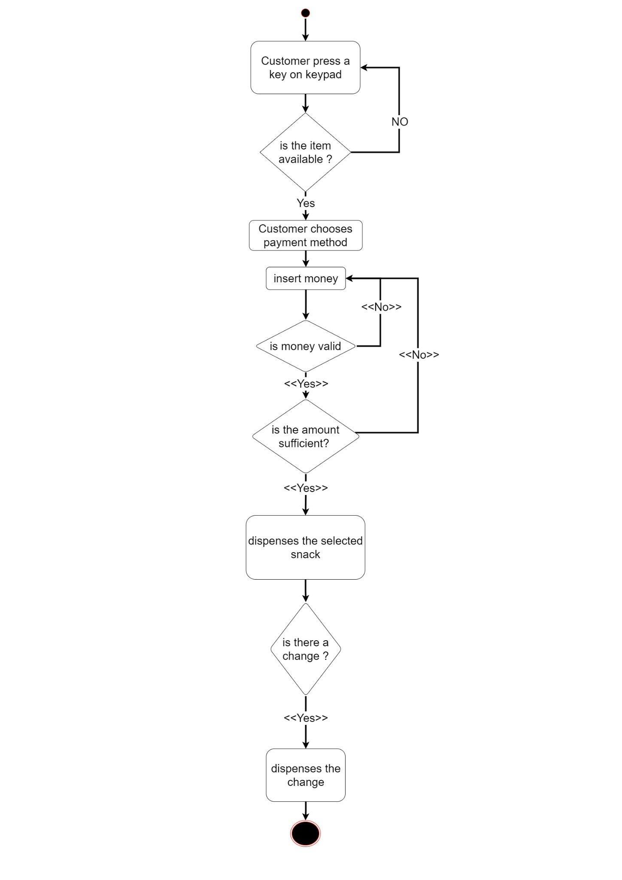
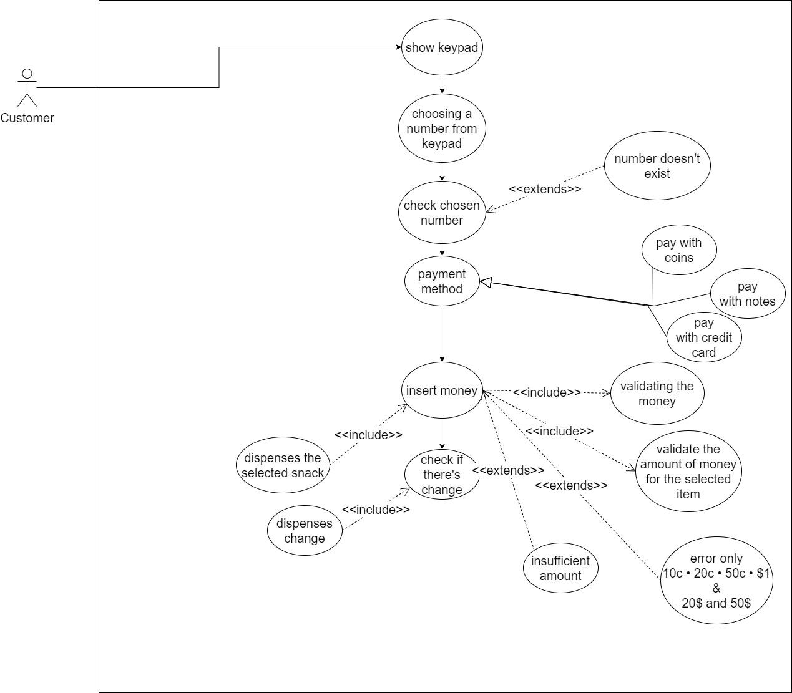

Purchase a Snack Use Case

Basic Flow
- This use case begins when the customer wants to purchase snacks.
- The customer selects a number by pressing on the keypad.
- The VM displays a message that the snack is available for the selected number and displays its price.
- The customer inserts the money.
- The VM validates the money.
- The VM accepts the money.
- The VM displays the accumulated amount of money each time a new money is entered.
- The VM monitors the amount of the accepted money, If the money is enough, the VM dispenses the selected snack to the customer.
- The VM determines if any change should be sent back to customer.
- The VM displays the change at panel.
- Then, the VM dispenses change.

[ P.S You are required to come up with alternative scenarios to this basic flow.]

